

***SZABIST (KHA)***

***JANUARY, 2021***

***CSCL1103 FUNDAMENTALS OF PROGRAMMING***

***(DR. AAMIR ZEB)***

***PROJECT: RESTAURANT MANAGEMENT SYSTEM***

***BY,***

***ALI ZAFAR QURESHI (2012374)***

***MUHAMMAD OWAIS KHALID (2012396)***

***JAVERIA SHAIKH (2012386)***

**ACKNOWLEDGMENT:**

Thank you to all of those members who helped in creating the project and to all the teachers who cleared the concepts of the participants of the project. Their hard work is showing the true shining colors. The participants of this project are

* Ali Zafar Qureshi (2012374)
* Muhammad Owais Khalid (2012396)
* Javeria Shaikh (2012386)

**REASON TO MAKE THIS PROJECT:**

The moto to make this program is to enhance the experience of user and to manage the time of the customer. The group members of this project realized that there should be a program which will save dealing between the customer and employees and will save overcrowding. After using our software, the customer would come every time because it would attract others to make an order from that restaurant since it is a big innovation in restaurants.

The advantage of the program is that there is no need to hire a person for the same only a system is required to execute it. The customer can work on the program and select the items which he or she wants to order.It is user friendly.

**ABOUT THE PROJECT:**

This project is all about to introduce an innovation in which software will take orders from the customer and will make a receipt of it. Not only this, this software would attract new clients and enhance the experience of the client and client would remember his experience which will make him to come back every time to restaurant whenever he wants to eat. This software can also be implied on the departmental stores but we, the members of this group certainly pointed out the restaurants. The main objective of this project is to develop a model which deals with Restaurant Management System. The system has 2 parts first of the customers and the other for the management side.

The customer side allows the customer to view menu list according to the time of delivery he desired and at the management side the staff is allowed to edit information regarding menu list, price, assigning cook, maintains information regarding the orders placed, etc.

**Algorithm:**

Step 1: start

Step 2: Prompt the user to the control panel.

Step 3: show the variety of variety of food. i.e. Chinese, desi or fast food. If user enters 4.back then move to step 2.

Step 4: display the menu accordingly. If user enters 4.back then move to step 3.

Step 5: prompt the user to select the food from the menu.

Step 6: Ask for the quantity of the food he wants to consume.

Step 7: Prompt the user to the total billing.

Step 8: Ask for his personal details i.e. name, address, phone no. etc.

Step 9: Display the receipt of his payment

Step 10: End.

**Flowchart:**

Delete record

Record List

Records

Exit

Back

Admin Panel

Prompt the user to the control panel.

Add record

Login with username and password username and password

Customer Panel

Types of

food.

3. Chinese Food.

2. Desi Food

1.Fast Food

Display Chinese Food Menu

Back

Display Fast Food Menu

Display Desi Food Menu

Type of food order

Quantity

Receipt

**Code**

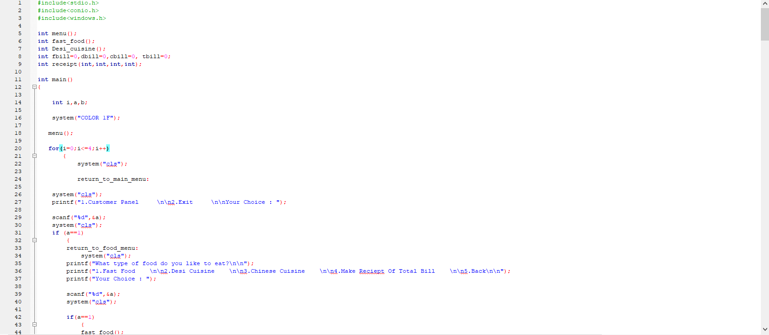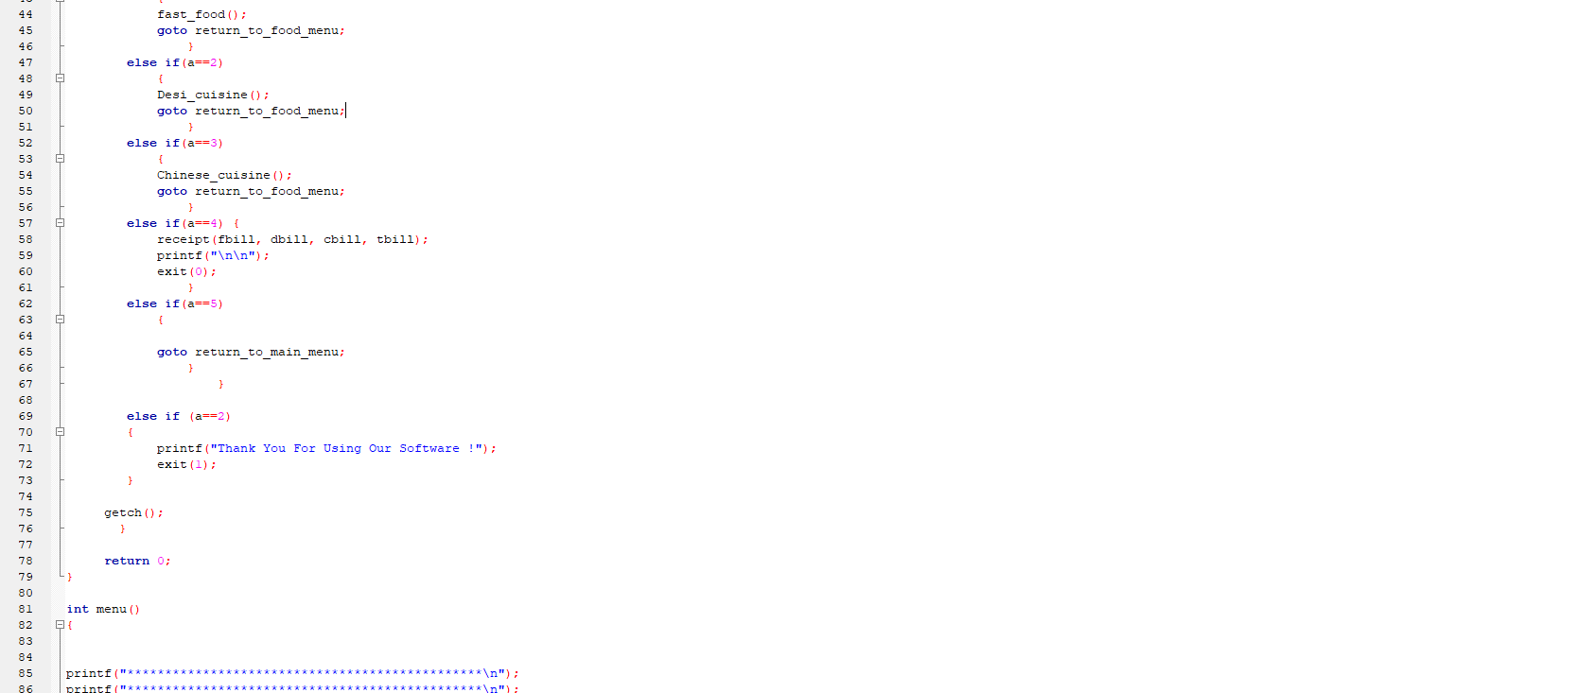

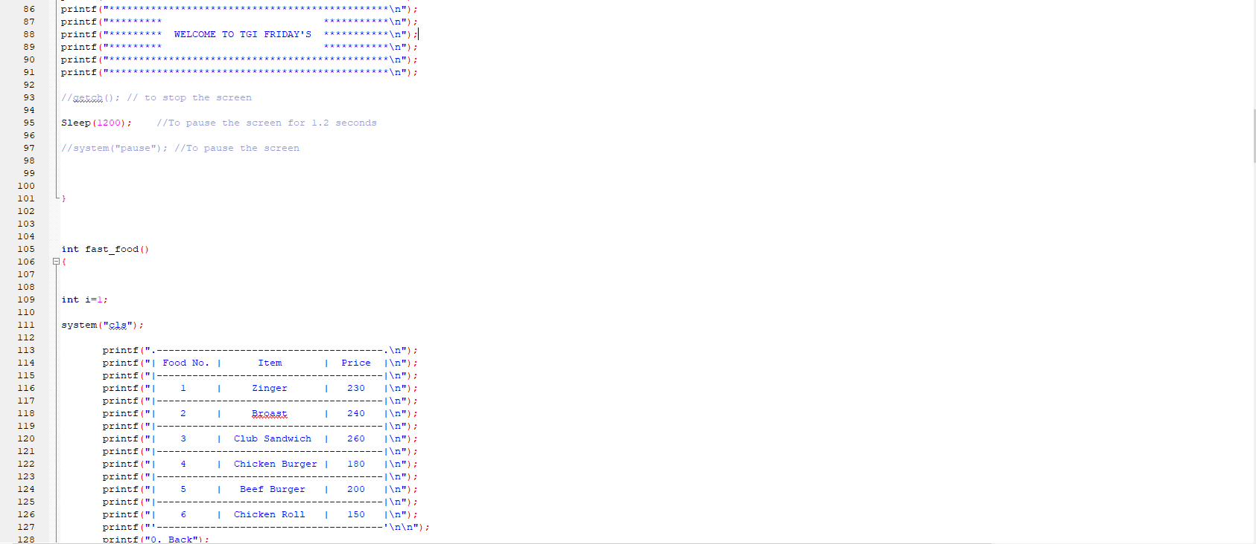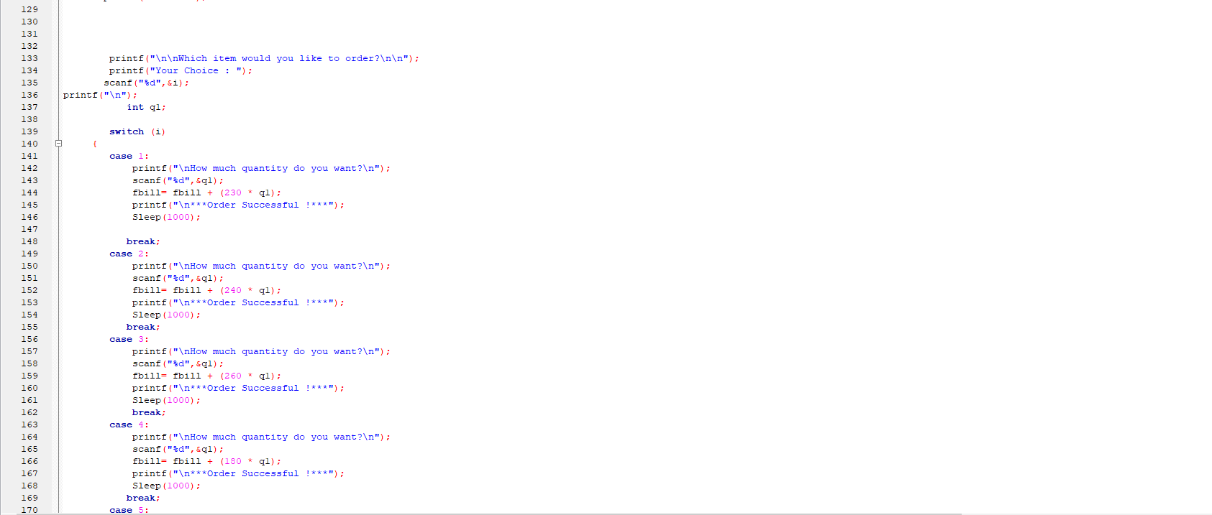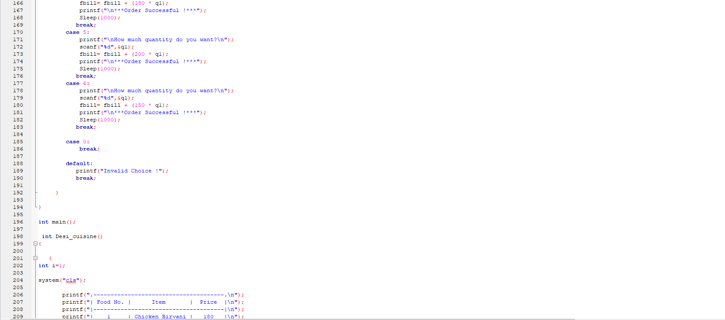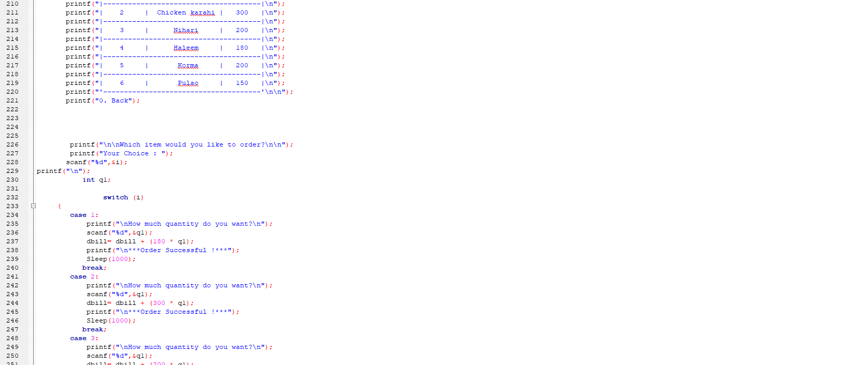

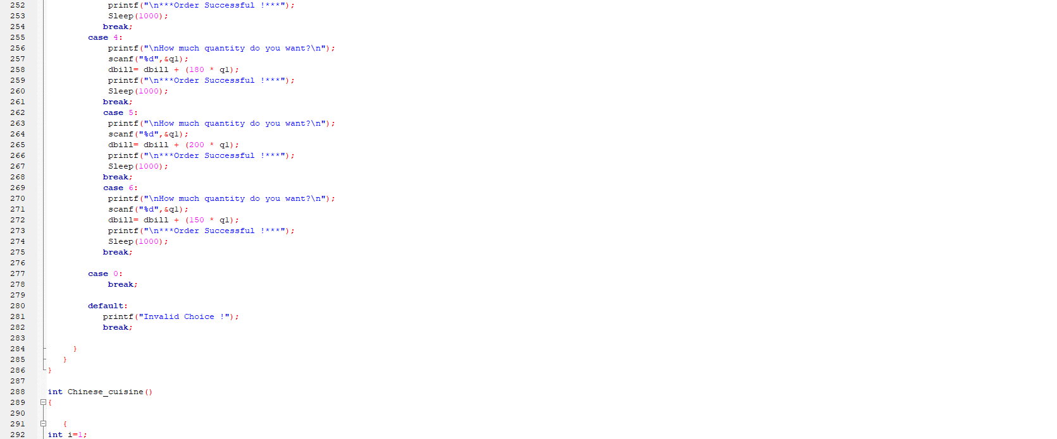

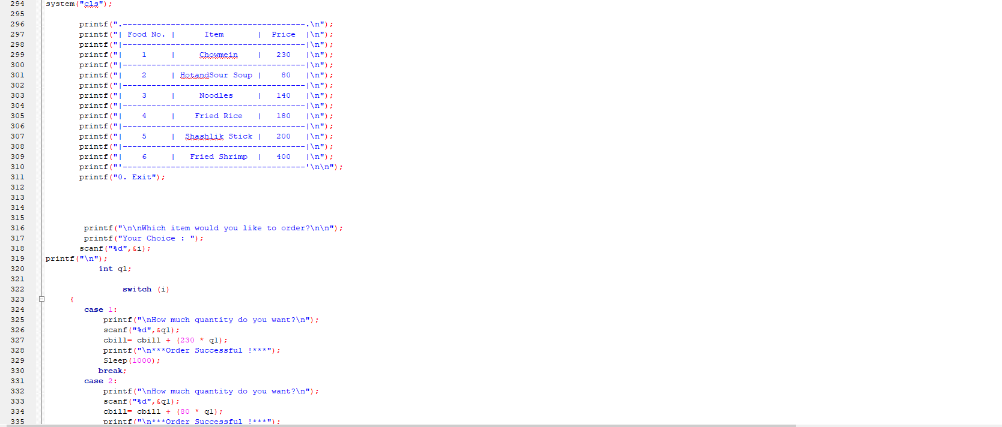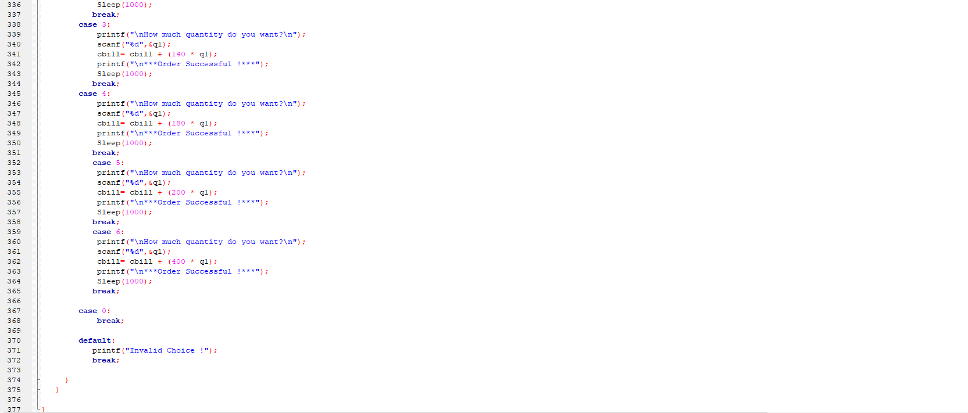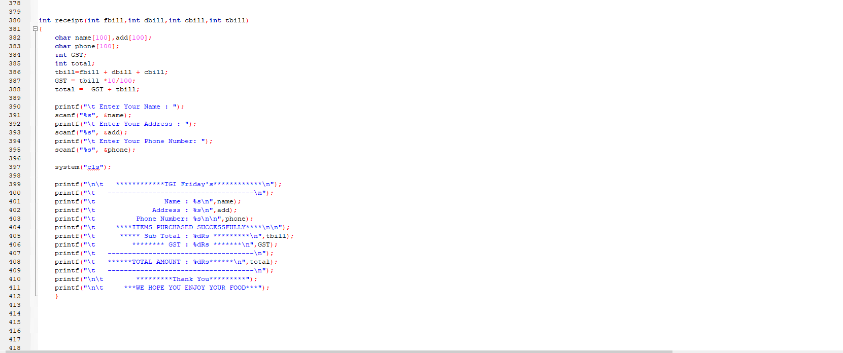

**CHALLENGES:**

The challenges faced in duration of making this program was to make it simple. Its interface must be elegant but simple to enhance the experience of the customer. One more challenge we can face is a data backup, the orders taken by this program is not being backed up which can cause an issue in fake orders or something like that. Since it is a very innovative thought of creating this program, it wasn’t easy to be made.

**EXPERIENCE:**

Things I’ve learned from this project are:

* How simple algorithms can solve a problem in just few lines of code rather than hundreds of them.
* How to store, call and manipulate variables.
* How structures can reduce the need to make multiple variables for each new function.
* How if and if-else statements are used.